Client Application:

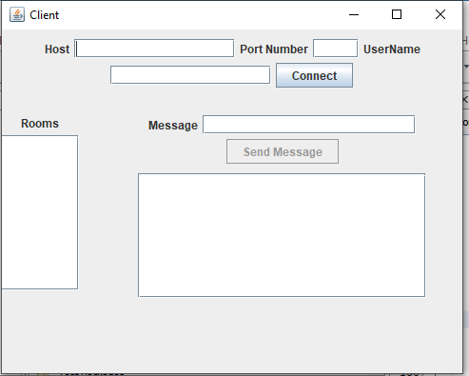

Server Application:

Enter Required Fields To Connect Server:

Now Connect to Server:

If You’re Successfully Connected You will Get this message otherwise error Will be Populated.

And You will available rooms from server in the rooms list.

Now you can send Message to others server and other Users.

